**Mansoor Mirza | 200978**

**COmputer Network lab**

**Exam Final**

|  |  |  |  |
| --- | --- | --- | --- |
| **IP Addresses** | **Class** | **N.H.D** | **Subnet mask** |
| **193.34.23.1** | C | N.N.N.H | 255.255.255.0 |
| **199.80.60.110** | C | N.N.N.H | 255.255.255.0 |
| **224.254.254.254** | D | N/A | N/A |
| **108.80.10.1** | A | N.H.H.H | 255.0.0.0 |
| **120.1.1.1** | A | N.H.H.H | 255.0.0.0 |
| **12.11.12.22** | A | N.H.H.H | 255.0.0.0 |
| **66.77.88.80** | A | N.H.H.H | 255.0.0.0 |
| **134.200.234.12** | B | N.N.H.H | 255.255.255.0 |
| **223.254.254.254** | C | N.N.N.H | 255.255.255.0 |
| **100.100.100.100** | A | N.H.H.H | 255.0.0.0 |

**Q1:**

**Q2:**

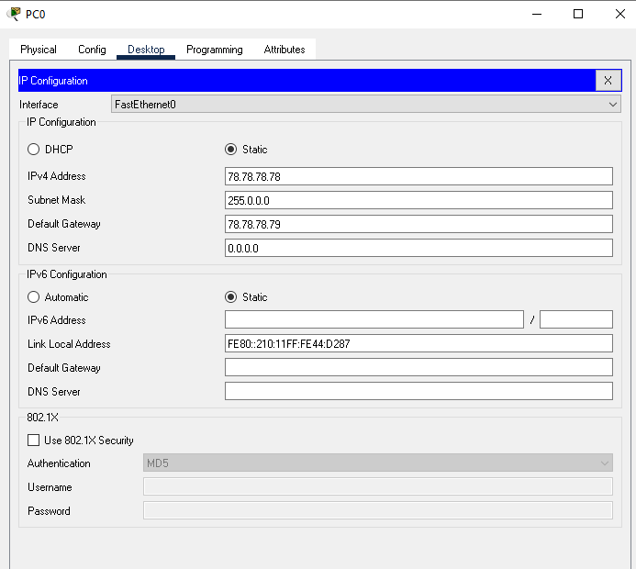

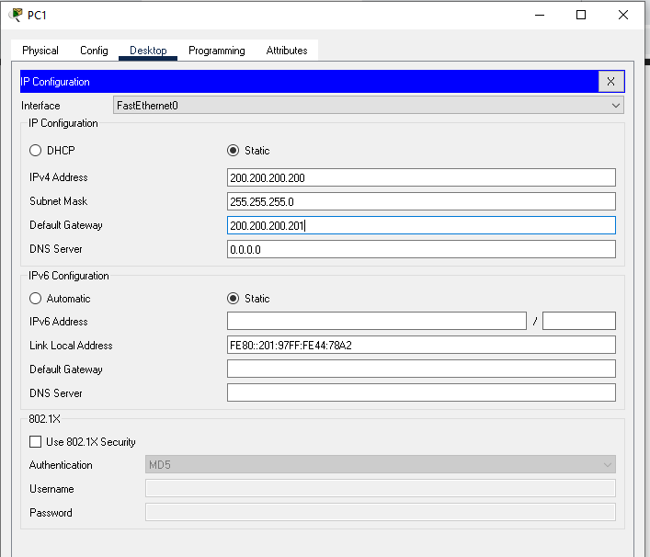

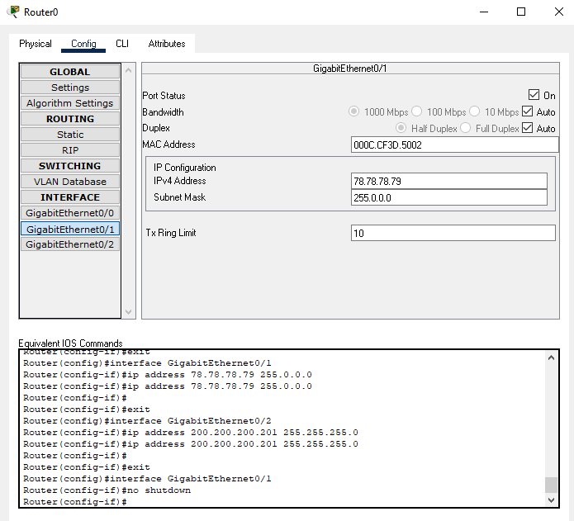

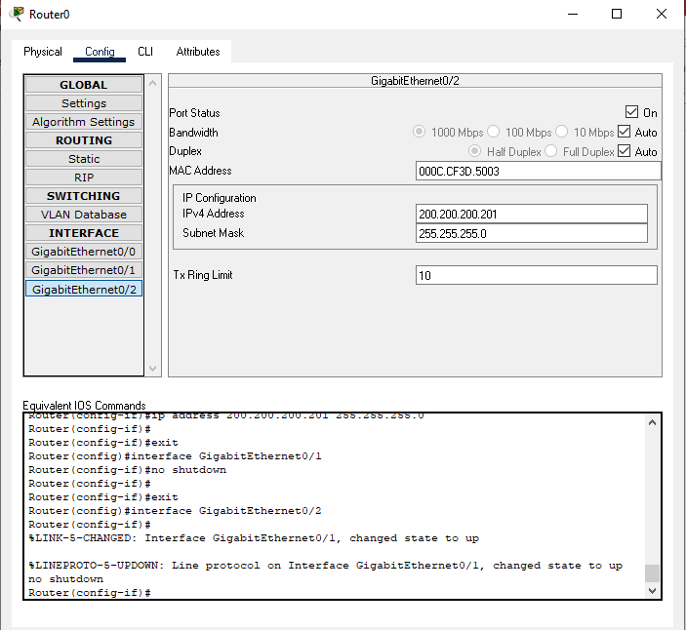

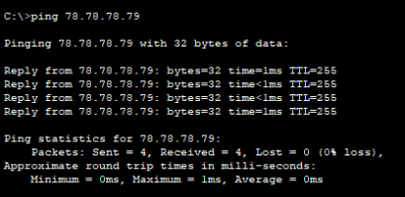

**Q3:**

